- JUNE 26, 2009

Nestlé Unit Denied FDA Requests

By JANE ZHANG
The Nestlé USA plant at the center of a federal probe into an E. coli outbreak involving cookie dough refused to give inspectors access to pest-control records, environmental-testing programs and other information, according to newly released inspection reports covering the past five years.
In a September 2006 visit, for example, managers at the Danville, Va., plant refused to allow a Food and Drug Administration inspector to review consumer complaints or inspect its program designed to prevent food contamination. The inspector found dirty equipment and "three live ant-like insects" on a ledge but nothing severe enough to give the plant a failing grade.
A year earlier, officials at the Nestlé plant presented another FDA inspector with a list of things it wouldn't do. "Among these are the refusal to review the firm's consumer complaint file, refusal to permit photography, refusal to sign affidavits or receipts and refusal to provide specific information on interstate commerce," the inspector wrote.
View Full Image
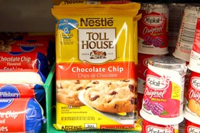
Getty Images
Cookie-dough production at a Nestlé USA plant was suspended last week.

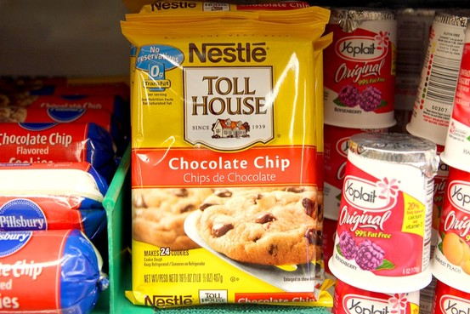
Companies aren't required to show those records to FDA inspectors and Nestlé's practice isn't out of line with the rest of the food industry, FDA and industry officials said.
Nestlé USA spokeswoman Edie Burge said she couldn't immediately comment on the reports Thursday, but said the company is cooperating with the FDA investigation. Since Friday, she said, the FDA has been examining all production and environmental records and testing finished dough samples, but hasn't found any contaminations there.
Nestlé USA, a unit of Switzerland-based Nestlé SA, suspended cookie-dough production at the plant June 18, but has continued to make pasta and sauce there, Ms. Burge said. The company has recalled 300,000 cases of refrigerated cookie-dough products.
David Elder, director of regional operations at the FDA's Office of Regulatory Affairs, said many food companies do open their records to inspectors. But the agency, he said, doesn't have explicit authority to access any records during regular food-safety inspections, with the exception of infant formula, seafood, juices and low-acid canned food.
The FDA can inspect the records if it invokes a bioterrorism law and shows that the agency has "a reasonable belief" that the foods pose serious health threats -- a high bar to cross.

More
- FDA Inspection Report 1
- FDA Inspection Report 2
The reports, released by the FDA in response to a Freedom of Information Act request by The Wall Street Journal, come as FDA investigators comb the Danville plant for clues to the E. coli outbreak in 29 states that sickened at least 69 people, including 34 who ended up in the hospital. Most of those sickened were teenage or preteen girls, and no deaths have been reported.
Legislation moving through the House would require food companies to keep more records and give FDA inspectors access to all records during inspections. The House Energy and Commerce Committee recently approved it, but it isn't clear when the House will vote on it. Similar legislation has been introduced in the Senate.
The legislation would "really change the dynamics of the situation" on record access by the FDA, said Stuart Pape, managing partner at Patton Boggs LLP who has represented the food industry for 35 years.
Write to Jane Zhang at Jane.Zhang@wsj.com
Printed in The Wall Street Journal, page B1

