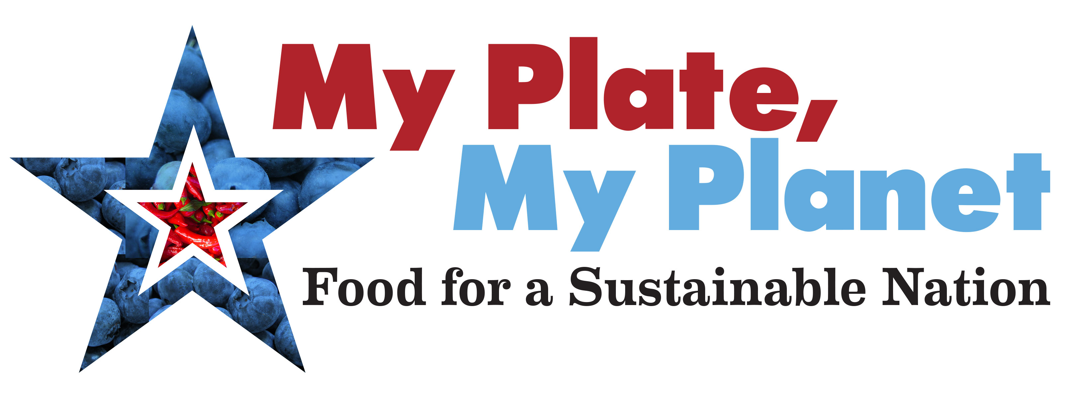

For Immediate Release Contact: Kate Reutersward
March 24, 2015 o: 202.339.9598 / c: 616.745.0198

Environmental and Health Leaders Show Support for Historic Inclusion of Sustainability Language in 2015 Dietary Guidelines

Environmental and Public Health Leaders Reach Consensus On Recommendations Addressing “Environmental Impact" of Current U.S. Diet

(Washington, DC) In a show of force, more than one hundred signatories from the nation’s leading environmental organizations and thought leaders are publicly supporting the recommendations of the 2015 Dietary Guidelines Advisory Committee (DGAC). Three ads in major daily newspapers feature an open letter urging Health and Human Services Secretary Sylvia Mathews Burwell and Agriculture Secretary Tom Vilsack to adopt the DGAC’s scientific recommendations on sustainability.

The signatories include Conservation International, Greenpeace USA, the League of Conservation Voters, the Natural Resources Defense Council (NRDC), the Sierra Club and many others. The public statement is being issued as stakeholders converge on Tuesday for a public hearing on the DGAC’s Scientific Report at the National Institutes of Health.

“What we are seeing with the Dietary Guidelines is a rare consensus between the environmental, public health, and nutrition communities,” said Rhea Suh, President of NRDC. “Policymakers should pay attention to this broad agreement on the historic sustainability language.”

If adopted, these recommendations have the potential to fundamentally transform American consumption patterns and shape USDA and HHS policy on a wide range of food and nutrition issues, from WIC benefits to school lunches and beyond.

The DGAC calls for eating more whole and plant-based foods and less meat as important for improving the health of Americans. Additionally, it emphasizes the importance of incorporating sustainability into dietary guidelines to help ensure the viability and availability of nutritious diets, both today and in the future.

The DGAC’s report recommended "a diet higher in plant-based foods, such as vegetables, fruits, whole grains, legumes, nuts, and seeds, and lower in calories and animal-based foods is more health promoting and is associated with less environmental impact than is the current U.S. diet.”

Regarding sustainability, the DGAC noted that:
- "Current evidence shows that the average U.S. diet has a larger environmental impact in terms of increased greenhouse gas emissions, land use, water use, and energy use."
- "Linking health, dietary guidance, and the environment will promote human health and the sustainability of natural resources and ensure current and long-term food security."

Groups representing the interests of industrial agriculture have decried the sustainability language in the recommendations as exceeding the DGAC’s mandate. Environmental and health leaders are responding forcefully, sending a message to policy leaders that the time has come for the US to join global efforts linking sustainability and nutrition.

A petition organized by Center for Biological Diversity, Johns Hopkins Center for a Livable Future, Friends of the Earth and Healthy Food Action – and joined by several other top environmental and public health groups – has already gained more than 100,000 signatures from Americans asking Secretaries Burwell and Vilsack to support the DGAC’s sustainability recommendations. Read the full petition here: http://bit.ly/1Fv5Obl.

For more information, please visit My Plate, My Planet: Food For A Sustainable America at www.myplatemyplanet.org

